Dataset pdf

The zip file for the dataset was way to large, but I did not want to mess with it more than I had to.

The link for downloading the dataset is:

<http://storage.googleapis.com/download.tensorflow.org/data/mini_speech_commands.zip>

Also, so you don’t have to download 177,000 KB of data, I provide some brief screenshots of how the datasets looked like: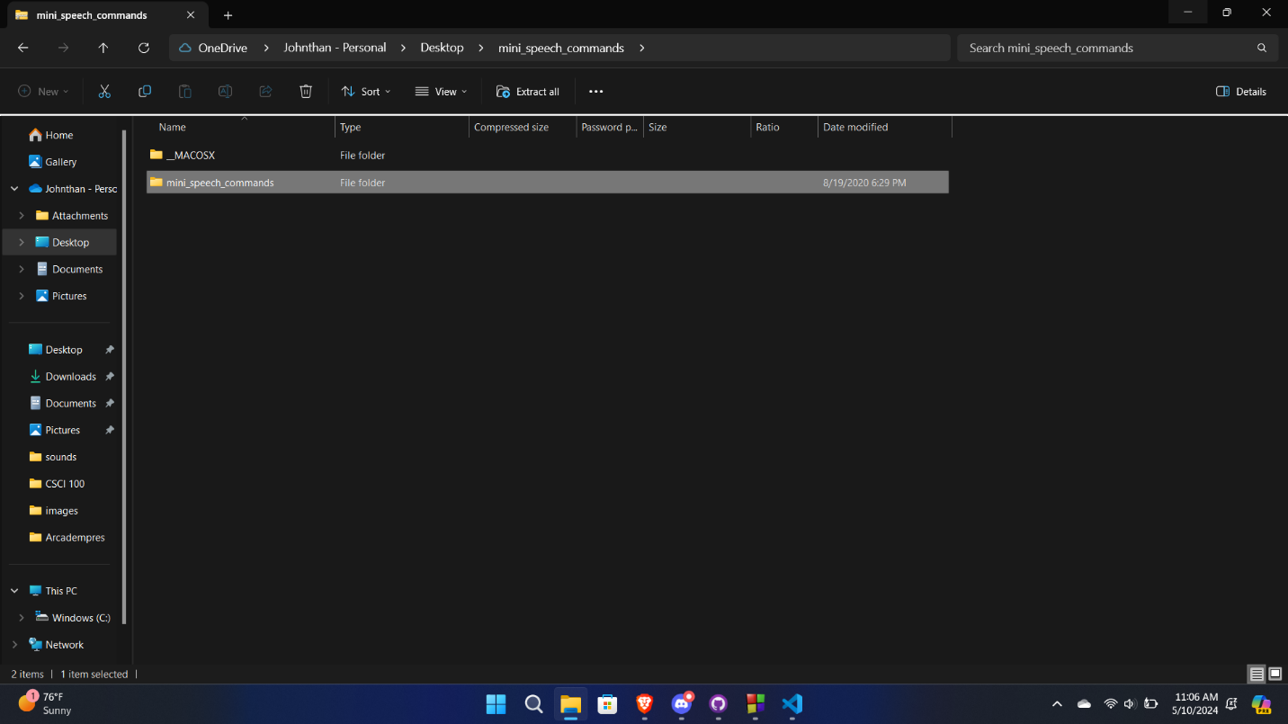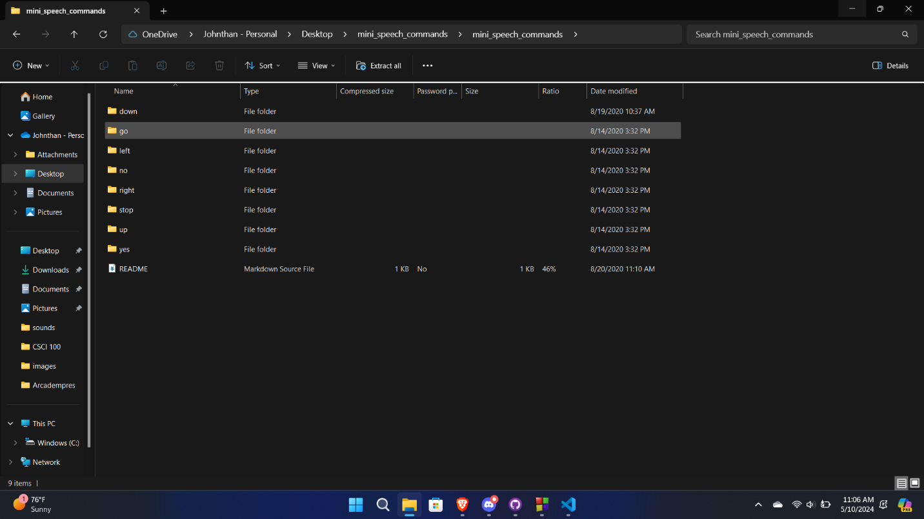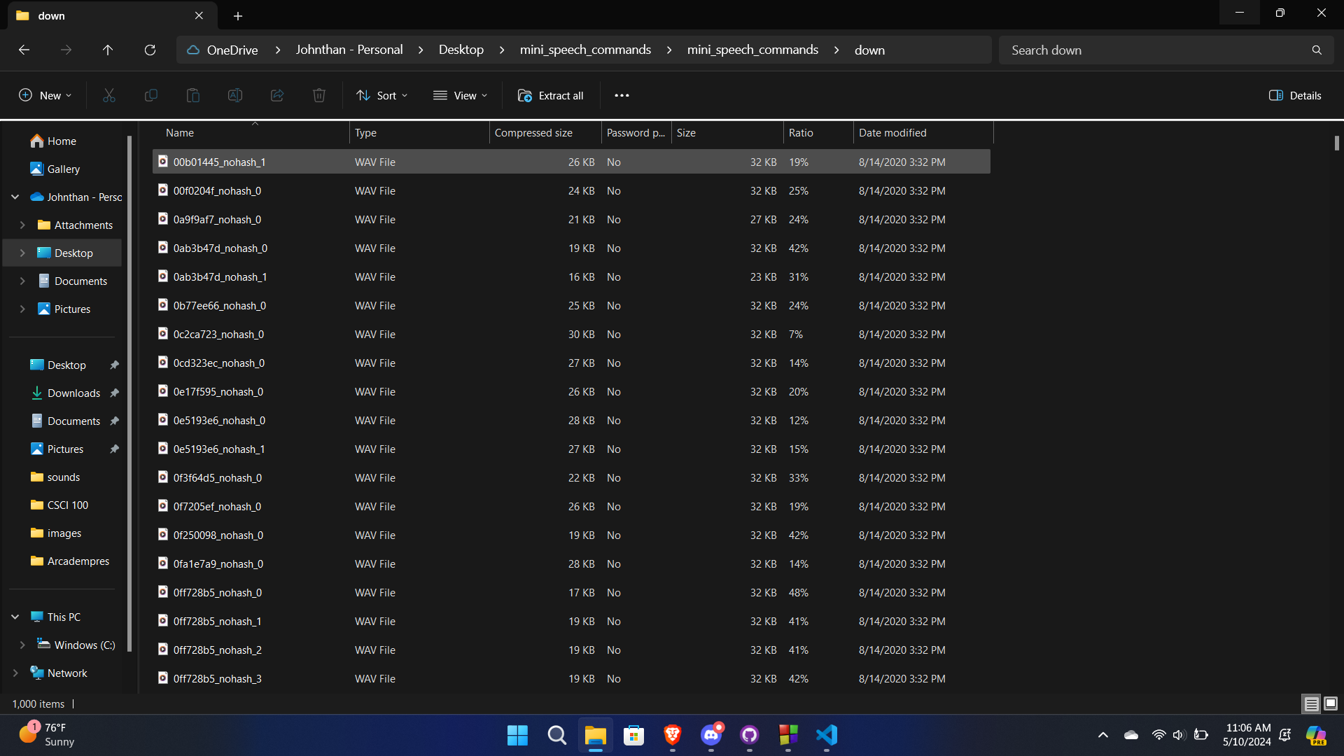

Along with this the following PDF we will have a folder with some samples from this dataset and a different folder with some samples of my personal recordings for testing.